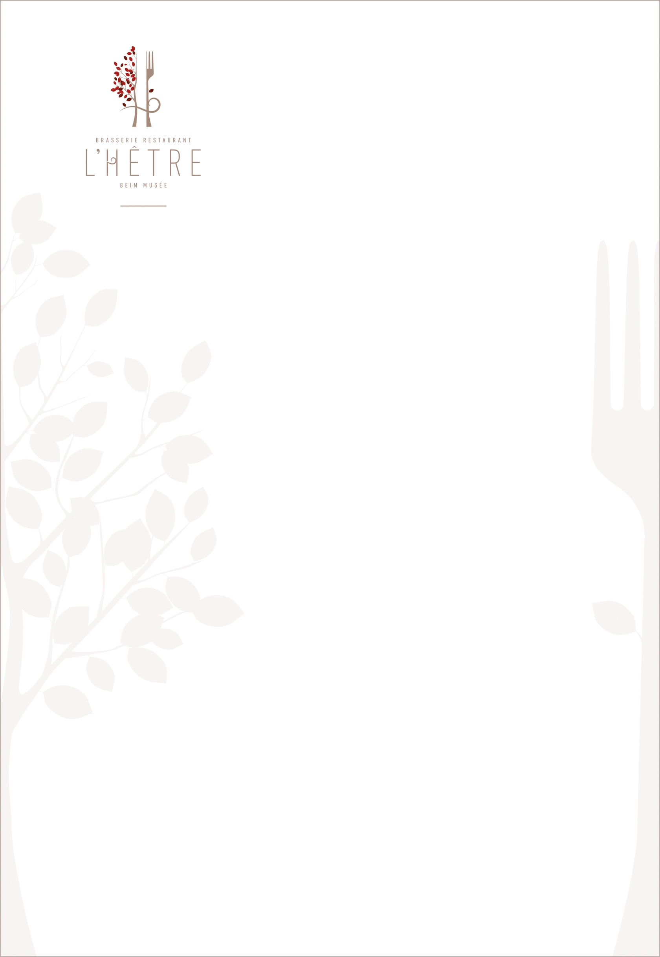

STARTERS

(Served with fries as main course)

Zuchinni flower stuffed with ricotta 23€/30€ Serrano ham,

Griled vegetables and smoked pepper sauce

Burrata & green asparagus

Asparagus gaspacho & granola 22€/29€

Méditerranean octopus grilled 24€/34€   
tomato sambol and glazed eggplants

VEGAN CORNER

Asparagus & red fruits . 18€ /25€ en plat  
fresh herbs sauce fried polenta 

Roasted coli flower with spices, 18€ /25€ en plat  
cheak pea houmous, vierge sauce and fried onions



Roasted eggplant with spices, 18€ /25€ en plat  
herbs sauce and tomato sambol, quinoa salad

LAND

Stuffed farm lamb saddle 34€   
vegetables and iberican chorizo, gravy, spring vegetables and beens ragout with parsley

Grilled iberican pork ribeye 29€   
spring vegetables baby potatoes   
gravy

Roasted veal filet, morrel sauce,, 39€ green asparagus,, mashed potatoes

TO SHARE… OR NOT !

Tuna “rillette” flavored with taragon 12€ Toasted focaccia

Homemade focaccia with parmesan cheese 18€  
mortadella, Buffala & pistachio

Homemade focaccia with salmon 19€  
marinated salmon,, black olives tapenade

Red onions pickles

Delicatessen plate. 19€ ham, sausages & cheeses, selected by us

HOMEMADE PASTA

Beef ravioli with herbs, 24€ gorgonzola sauce and baby vegetables

Orrecchiette with rabbit stew 24€   
dried tomatoes and mushrooms

Salmon ravioli 24€ lemon butter sauce, pesto verde & cime di rape

Linguine with organic shrimps 28€ vegetables, gremolata ,seafood sauce

TARTARE, CARPACCIO & TATAKI

(Starter or main course +9€ )

**Served with fries as main course**

Simmental beef carpaccio 21€ grilled vegetables, baby leaves & Parmegiano Reggiano

Salmon and dill carpaccio 21€ grilled vegetables, baby leaves

Luxembourgish beef tartare 21€  
green salad and crunchy vegetables

Salmon and basil tartare 21€  
guacamole and spices

Angus beef tataki marinated with sesame. 21€ Coli Flower salad and peanuts acidulous dressing

Red tuna and lime tataki 22€ green asparagus and crunchy condiment

SEA

Sicilian style swordfish grilled shrimp 32€   
bagna cauda sauce,  
spring vegetables & quinoa croquette

Slowly cooked pollack & shells  
spring vegetables & fregola sarda 33€

LA

CARTE

CHEESE SELECTION 15,50€

Aged cheeses & toppings of the moment

ICE CREAM 3,5€/scoop

Vanilla Bourbon

Chocolate

Pistachio

Moka

SORBETS 3,5€/scoop

raspberry

lemon

strawberry

Apricot

CHILDREN PLACE

Rigatoni with cream and ham 12€

Rigatoni with bolognese sauce 12€

Breadcrumbed veal slice 17€  
fries and vegetables

SWEET TIME

Cheese cake 12,50€  
Red fruits raw and candied

rhubarb & strawberry tart 12,50€  
vanilla cream

Paris-Brest 12,50€  
homemade praliné & vanilla

Finger nougat & pistachio. 12,50€ vanilla cream, et citrus coulis

L’omelette Norvégienne 13,50€ Vanilla ice cream, strawberry sorbet, flambed in front of you !!

Baba au rhum, chantilly 14€

Greedy coffee 14€50  
3 differents small pastries

Greedy tea or herbal tea 15€50  
3 differents small pastries

NOS CLASSIQUES

Chateaubriand (for 2 pers mini)  
béarnaise sauce  
spring vegetables and fries

250 g per person 38€ /pers

Luxemburgish roasted chickenand served in a casserole  
Gravy, vegetables and mashed potatoes   
(20 min de préparation)

½ chicken (For 1 person) 25€

All chicken (For 2 persons) 50€

Mix grill of fish and seafood   
Chimichuri sauce grilled vegetables ans steamed rice 40€

